**Peanut worms**

Sipuncula -- These animals, which are commonly called "peanut worms" because some have the general shape of shelled peanuts, are not particularly well studied. Only about 320 species have been formally described, all marine and mostly from shallow waters. While some (like the specimen of Sipunculus shown below) burrow into sand and mud, others (like this unidentified species from French Polynesia) live in crevices in rocks, or in empty shells. Still others bore into rock. For instance, sipunculans have no trace of important annelid characters such as segmentation and chaetae (bristles). The characters they do share with annelids (e.g. worm shape, introvert, trochophore larva) are not restricted to annelids and sipunculans, but are much more general. These animals are now placed in a separate cades, but were once considered aberrant annelids. Now some believe they may even be more closely related to mollusks. a. Obtain a peanut worm and watch it move and feed. If possible take photographs or video its introvert. Try fishfood or beefheart.

**Please remember to record your observations in your journal.**

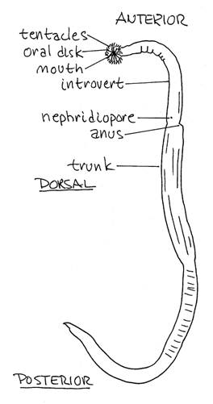

[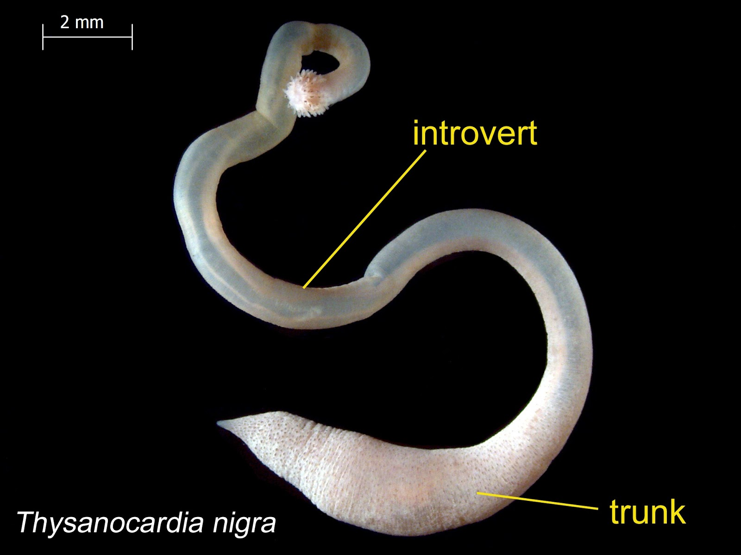](https://www.google.com/url?sa=i&rct=j&q=&esrc=s&source=images&cd=&ved=2ahUKEwiYtPy9kdTeAhXhmeAKHVoHAfoQjRx6BAgBEAU&url=http://ecologywa.blogspot.com/2018/01/eyes-under-puget-sound-critter-of-month.html&psig=AOvVaw2bdHxoI8NUUCqiijlXMKr7&ust=1542293521923547)



